USBprog 5.0
Stand 24.04.2015 / Dokument Version V111

© embedded projects GmbH

http://www.embedded-projects.net

Inhaltsverzeichnis
1. History 4
2. Overwiev USBprog 5.0 4
2.1. Hardware Overwiev 4
2.2. Prozessor Adaptor 5
3. Quickstart 6
4. Installation 7
4.1. Linux 7
4.2. Mac 7
4.2.1. System requirements 7
4.2.2. Installation of the USB-Network 7
4.2.3. Installation of Python 7
4.3. Windows 7 (translated (german pictures)) 8
4.3.1. Installation of the USB-Network 8
4.3.2. Instalation of embeddedprog.exe 12
4.4. Windows 8.1 (translated (german pictures)) 12
4.4.1. Installation of the USB-Network
12
4.4.2. Installation of the embeddedprog.exe 16
4.5. Other OS 16
5. Controls 17
5.1. Controls in Browser 17
5.1.1. General information 17
5.1.2. Choosing Settings 17
5.1.3. Using the „Commands“-Area 17
5.1.4. Programing Firmware 18
5.1.5. Using the Flash Archive 19
5.1.6. How to update the USBprog 5.0 19
5.1.7. commandline arguments 19
5.2. Controls in Console 20
5.2.1. How to open a Console/Shell 20
5.2.2. Download the Commandline Tool 21
5.2.3. Using the Commandline Tool 21
5.2.4. The Arguments 22
6. Using the USBprog 5.0 with Atmel Studio 23
6.1. Creating the functions 23
6.1.1. Entry„Program“ 24
6.1.2. Menu entry „Open Settings“ 25
6.2. Using the Menu Entry 25
7. Einrichten des USBprog 5.0 als Programmer für Eclipse (not translated) 28
8. Update Firmware 30
9. Debug with OpenOCD 31
9.1. Debugging via Command line/Shell 31
9.1.1. Linux 31
9.2. Debuggen mit Eclipse ( not yet Documented ) 34
10. USBprog 5.0 System details 34
10.1. Open-Source Programs 34
10.2. GPIO Routing 34

History

Date | Version | Notes | Editor
2015-04-30 | V111 | A few Translations. | Jannis Barth
2015-05-06 | V111 | Complete Translation | Jannis Barth

Overwiev USBprog 5.0
The Usbprog 5.0 is an integrated programer with hard and software included. Through a USB connection to the PC a network is established, with which the programer can be easely controlled. Connection can be made via the browser or a commandline tool. Its possible to flash both ARM and AVR processors. Additionaly its possible to start and use the integrated openocd debugger.
Additional Features like the flash-archive allows saving and easy usage of a finished firmware. The flash-archive is saved on the USBprog 5.0 so it wont be lost unless it is deleted.

Hardware Overwiev
The USBprog 5.0 has 3 interfaces: USB ( for network emulation and power supply ), a 10 pin program and debug interface ( for pin routing look at 10.2 ), and the 14 pin standart Gnublin/EEC interface, which already has many extension (for example: Display, Engines, AD-Converter, temperature-sensor …).
To fit the Voltage for different processors a voltage regulator is build in which can select 1.8V 3.3V and 5V.
The remainder of the Board has an processor and internal memory on which a linux system is running. The Linux OS is booted from an SD-card. Updates are aviable in the official git and can be inputtet via the internal browser. If anything should ever go wrong a complete image can be found in the Download section.
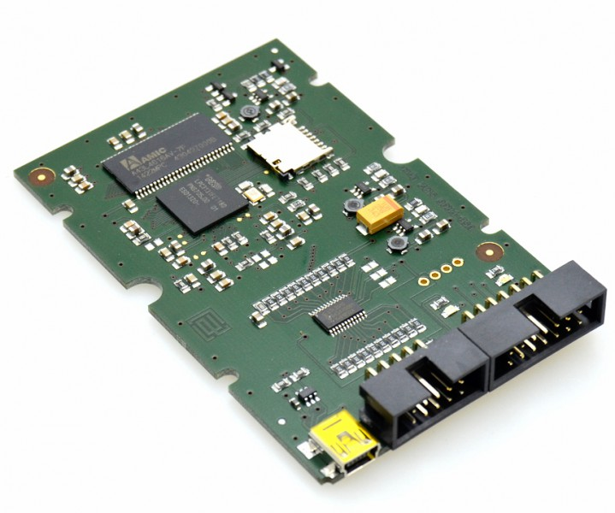Abbildung 1: USBprog 5.0

Prozessor Adaptor
The processors are connectet via a 10 pin program and debug interface. The mapping is the standart of all Usbprog versions, it is the same as the 10 pin AVR ISP interface. Meaning if a 10 pin AVR Target Board is to be flasehd the USBprog 5.0 can be conected 1:1.
To connect to a 6pin AVR an 10 to 6 adaptor is needed ( illustration 3 ). For ARM processor an 10 to 20 adaptor is needed ( illustration 3 ). more adaptors for example for pic will follow.
.
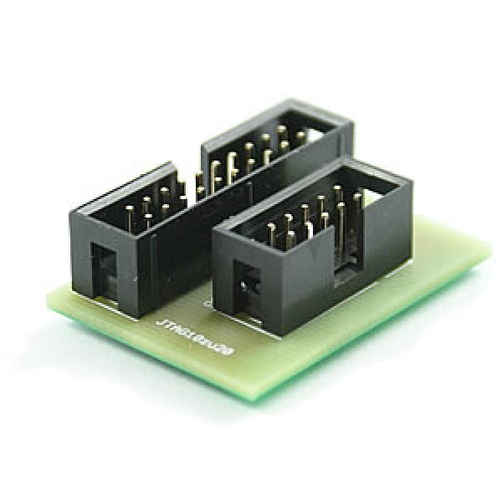Abbildung 2: ARM 10 auf 20
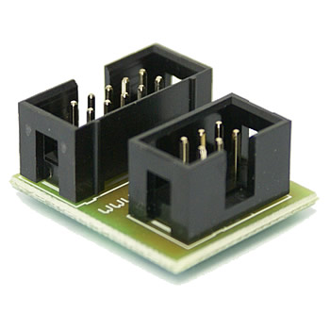Abbildung 3: AVR 10 auf 6

Quickstart

In the USBprog is the complete hard and software needed to programm microprocessors.The tools can be reached via browser or shell/command line.

The standart aproach is:

- Connecting the USBprog 5.0 via USB
- After installing the necessary drivers (described in chapter 4) a network connection with the USBprog will be etablished.
- The red LED signals that the USBprog has booted.
- Connect under http://10.0.0.1 with the browser or with the commandline tool.
(It can take a few seconds for the network connection to be ready..)

Installation
To use the USBprog 5.0 a network with the pc has to be established. The commandline tool can be aquired from the git server or from the local website of the USBprog 5.0.

By default the ip of the USBprog 5.0 is: 10.0.0.1

Linux
By connecting the USBprog 5.0 via usb a network will be established and the pc gets an ip from the dhcp-server running on the USBprog.
If this by chance doesnt work its possible to open the shell (Cmd + Alt + t ) , stop the Network Manager and assign an ip yourself.
Needed commands:
sudo stop network-manager
sudo dhclient eth0
sudo ifconfig usb0 10.0.0.2 up

If python isnt installed please install it by typing:
sudo apt-get install python

After connecting the USBprog via usb it will take roughly 10-30 seconds for the red LED to switch on, after another 10-30 seconds the USBprog is ready for a connection from the browser or the commandline tool.

Mac

System requirements
MacOS X 10.6.3 or newer.

Installation of the USB-Network
By connecting the USBprog 5.0 via usb a network will be established and the pc gets an ip from the dhcp-server running on the USBprog.
After connecting the USBprog via usb it will take roughly 10-30 seconds for the red LED to switch on, after another 10-30 seconds the USBprog is ready for a connection from the browser or the commandline tool.

Installation of Python
Python is included in the newest MacOS X versions.

Windows 7 (translated (german pictures))

Installation of the USB-Network

- Press the start button and from there go to the Control Panel. ( Start/Settings/Control Panel illustration 4 ).
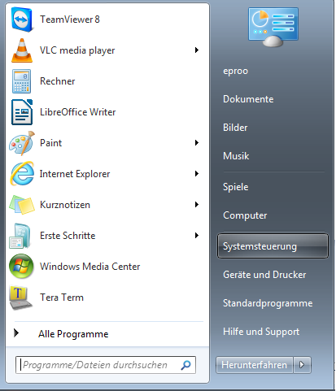Abbildung 4: Systemsteuerung öffnen
- Open the Device Manager (Start/Settings/Control Panel/System/Hardware/Device Manager . Illustration 5)
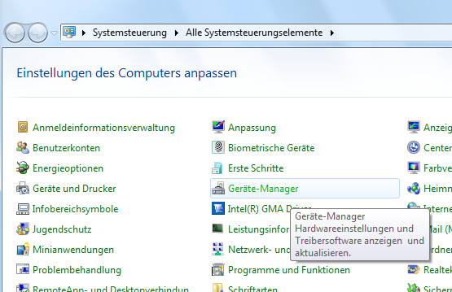Abbildung 5: Geräte-Manager wählen
- Rigthclick the „RNDIS / Ethernet Gadget“ which is located in Other devices and choose the option „Update Driver Software...“ ( illustration 6 )
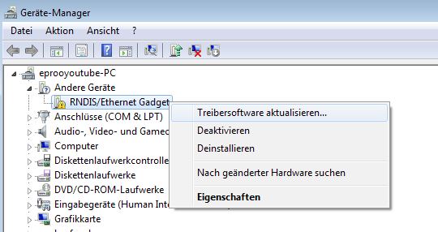Abbildung 6: RNDIS Gadget aktualisieren

- Choose “Browse my computer for driver software” ( illustration 7 )

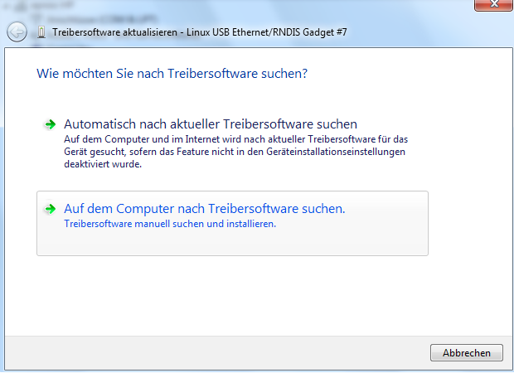Abbildung 7: Auf dem Compuiter nach Software suchen

- Now the options to select a path or to select from list should show up. Press select from list ( illustration 8 )
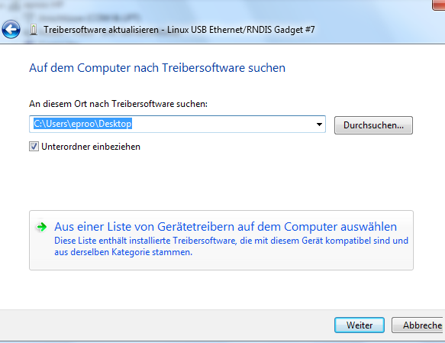Abbildung 8: Aus Liste auswählen

- Here the device type should be choosen, in our case „Network adapter“ (siehe Abbildung 9)
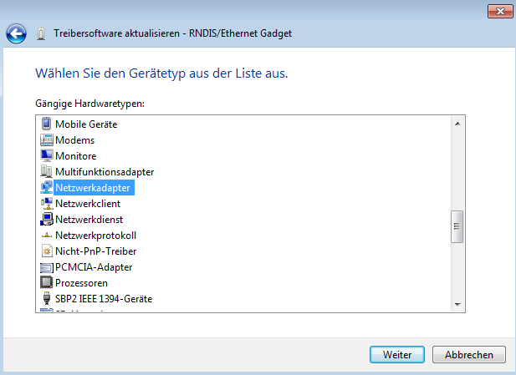Abbildung 9: Netzwerkadapter

- Now select "Microsoft Corporation" in the left window and "Remote NDIS based Interet Sharing Device" in the rigth window.( illustration 10 )
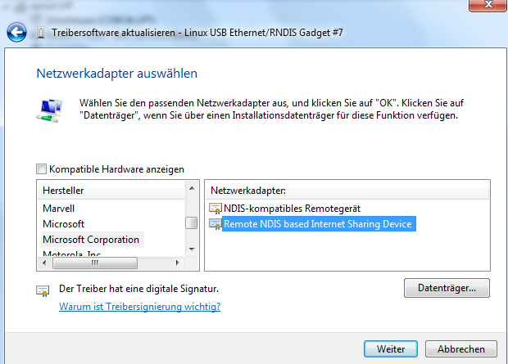Abbildung 10: Microsoft Corporation Remote NDIS

- The USBprog 5.0 is now Installed.
Generaly it takes 10-30 seconds, after connecting the USBprog 5.0 till the red LED turns on. After another 10-30 seconds the USBprog is ready.

Instalation of embeddedprog.exe
The setup.exe ca be downloaded from the internal browser ( http://10.0.0.1 ) and installed as any other .exe file.

Windows 8.1 (translated (german pictures))

Installation of the USB-Network
Write Device Manager into the windows 8.1 screen and press enter ( illustration 11 )

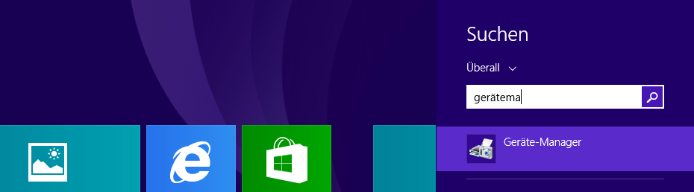Abbildung 11: suche Geräte-Manager

Rigthclick the „RNDIS / Ethernet Gadget“ which is located in Other devices and choose the option „Update Driver Software...“. ( illustration 12 )
Abbildung 12: RNDIS Gadget aktualisieren

Choose “Browse my computer for driver software” ( illustration 13)

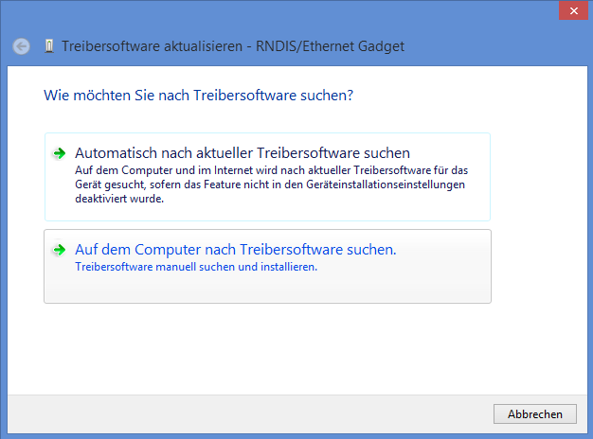Abbildung 13: Auf dem Compuiter nach Software suchen

Now the options to select a path or to select from list should show up. Press select from list. ( illustration 15 )

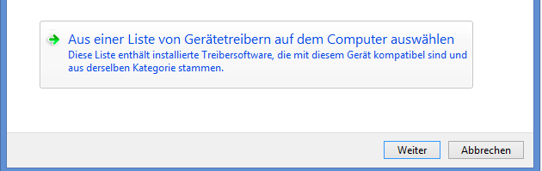Abbildung 14: Treiber aus Liste

Here the device type should be choosen, in our case „Network adapter“ ( illustration 16)
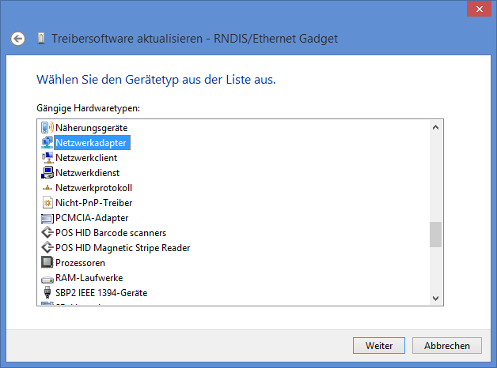Abbildung 15: Netzwerkadapter

Now choose "Microsoft" in the left window and "USB-RNDIS-Adapter" in the rigth window. ( illustration 17 )

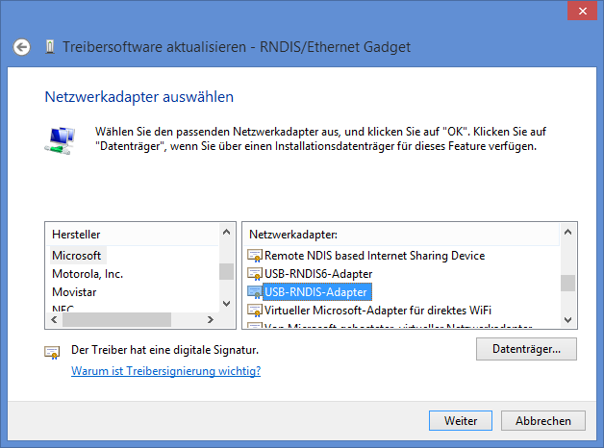Abbildung 16: USB-RNDIS-Adapter

After pressing Continue an warn message will be shown. This can be ignored, just select yes and install the driver ( illustration 17).
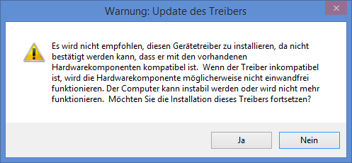Abbildung 17: Warnmeldung
The USBproog 5.0 is now installed.

Generaly it takes 10-30 seconds, after connecting the USBprog 5.0 till the red LED turns on. After another 10-30 seconds the USBprog is ready.

Installation of the embeddedprog.exe
The setup.exe ca be downloaded from the internal browser ( http://10.0.0.1 ) and installed as any other .exe file.

Other OS
At least python 2.7 is needed. This python has to be able to use the argparse funktion.
The OS needs to be able to etablish an USBNetwork.

Controls
The USBprog 5.0 can be controled via browser ( illustration 18 ) or via the commandline tool ( illustration 19 ).

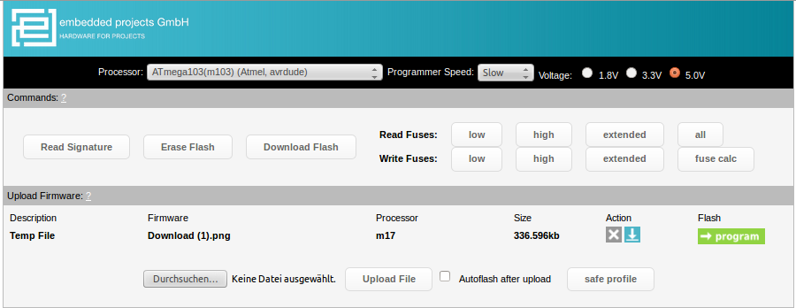Abbildung 18: Browser
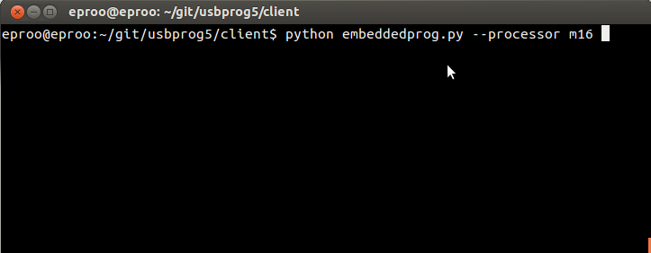Abbildung 19: Konsole

Controls in Browser
Controlling the USBprog 5.0 via browser is the most comfortable, becouse it has an graphic user interface.

General information
By default the IP of the USBprog is 10.0.0.1 and it can be reached under that adress in the browser.

Choosing Settings
In the settings area ( illustration 20 ) the processor, voltage and programmer speed can be selected. By clicking on the processor dropdown menu a processor can be searched, by typing in the processor name or looking for it in the dropdown menu. The menu is dynamic, so it shows all occurences containing the typed in characters.

The programmer speed can only be chosen for AVR at the moment, so it can be ignored for arm processors. By default the speed is set to fast.

Abbildung 20: Settings

Using the „Commands“-Area
After selecting a processor, the commands-area will be shown. The commands will all be executed with the previosly selected settings. This area is dynamic and will change based on the processor type (arm/avr).
Behind each processor AVR or ARM will be shown. This indicates which adapter should be used, the 10 to 6 for AVR ( illustration 21) and the 10 to 20 for ARM ( illustration 22).

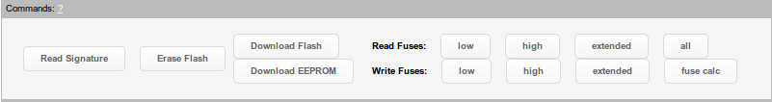Abbildung 21: Buttons AVR

Abbildung 22: Buttons ARM

Programing Firmware
Before uploading a file the correct settings ( illustration 20 ) should be chosen, to test them use the read signature button.
To upload new firmware click the browse button and select the file you want to upload, by clicking the upload button next it will be uploaded to the Usbprog, where it will be shown as an tempfile. By uploading a new file the old tempfile will be deleted, so you can save this „temporary profile“ by clicking the safe profile button. You will then be asked to type in the description for the current file.
If an EEPROM file is to be uploaded ( AVR only ) check the EEPROM-chekbox ( illustration 24 ).
Once an tempfile is uploaded ( illustration 23 ) the target board can be flashed. By selecting the autoflash checkbox the file will be programed onto the target board after the upload is completed.

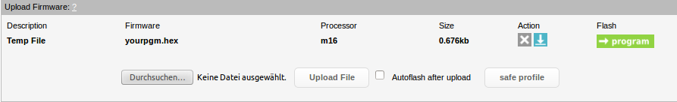Abbildung 23: Temporäre Firmware in der ARM Oberfläche
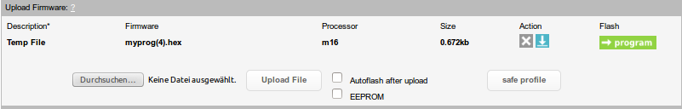Abbildung 24: Temporäre Firmware in der AVR Oberfläche

Using the Flash Archive
The files put in the flash archive ( illustration 25) behave like the tempfile. Press the X Action Button to delete the entry, the down arrow to download the file or the program button to program. Additionaly the description of an entry can be changed at any time by clicking on it and typing in a new description.

Abbildung 25: Flasharchive

How to update the USBprog 5.0
Siehe Punkt 5: Firmware Update und Punkt 3.2 Bedienung per Konsole

commandline arguments
In those illustrations ( 26, 27 ) you can see the commandline arguments for the corresponding buttons. This area changes according to the chosen processor type (avr/arm ). „your processor“ needs to be switched with your processor ( for example: lpc2103, m16 ..).

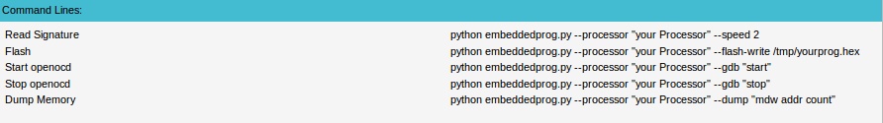Abbildung 26: Kommandozeilenbefehle ARM

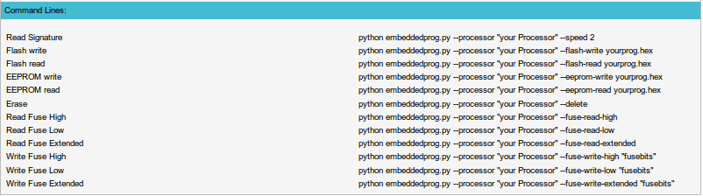Abbildung 27: Kommandozeilenbefehle AVR

Controls in Console
The controls via console/shell are more complicated then the usage of the browser becouse you only get text based feetback and you have to type in the commands yourself, but it yealds more information then the browser and offers more possibilitys.

How to open a Console/Shell
Linux:
Press cmd + alt + t.
Or select it in your menu.( its commonly called Terminal )
Windows:
Press the windows key + r, type in cmd and press enter.( illustration 28 )

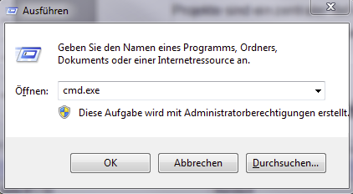Abbildung 28: Ausführen mit Windows

Mac:
Press cmd + space and type Terminal into Spotlight ( illustration 29 ).

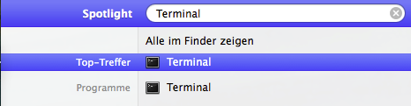Abbildung 29: Spotlight zum Aufruf des Terminal in MacOS

Download the Commandline Tool
The tool can be downloaded from the internal browser ( illustration 30 ) or directly from the git.

Abbildung 30: update programmer/ download Konsolen tool

Using the Commandline Tool
With the help option all possible arguments will be shown.

Linux/Mac:

python embeddedprog.py --help

or

python path/embeddedprog.py --help

Windows:

embeddedprog --help

The Arguments
All arguments not listed here ( shown by --help ) are meant for the browser or extern programms, its best not to use them without a deep understanding of the complete USBprog 5.0

Arguments | Description
-v | This value influences he USBprog 5.0 output. This doesnt influence the avrdude or openocd output. -v for more infos, -vv for many infos, -vvv for way to many infos ( just for debugging the USBprog )
--processor | Expects the processor that will be used. If its the only argument given it will output the Signature.
--speed | At the moment only useable in avr, defines speed. 1=fast, 2=normal, 3=slow.
--show-all | Shows all supportet processors.
--signature | Reads the processor Signature.
--voltage | Defines which Voltage to use. 1 for 1V8, 3 for 3V3, 5 for 5V.
Tabelle 1: Common Arguments
Arguments | Description
--eeprog-ip | Here an ip can be set for the USBprog. Default 10.0.0.1.( for port routing and similar uses )
--eeprog-port | Here an Port can be asigned. Default 8888. ( for port routing and similar uses )  Hier soll der Port des USBprog 5.0 angegeben werden. (Standard 8888). falls nichts angegeben ist wird der standart Port genutzt.
Tabelle 2: Config Arguments

Arguments | Description
--flash-write | Flases the Target Board with the file. (complete and relative path works).
--dump | Dumps memory with Openocd. Expects following form:  mdw [phys] addr [count]  mdw = 32-bit word mdh = 16-bit halfword mdb = 8-bit byte  When the current target has an MMU which is present and active, addr is interpreted as a virtual address. Otherwise, or if the optional phys flag is specified, addr is interpreted as a physical address. If count is specified, displays that many unit
--gdb | Starts/stops openocd (for debugging). Expects "start" or "stop"
Tabelle 3: ARM Arguments
Arguments | Description
--flash-read | Reads the target boards flash. Expects ( filepath ) filename
--flash-write | Flashes file to Target Board.
--eeprom-read | Reads the target boards eeprom. Expects ( filepath ) filename.
--eeprom-write | Flashes file to Target Board.
--fuse-read-low | Reads LOW Fusebit
--fuse-read-high | Reads HIGH Fusebit
--fuse-read-extended | Reads EXTENDED Fusebit
--fuse-write-low | Writes LOW Fusebits. expects 0xFF
--fuse-write-high | Writes HIGH Fusebits. expects 0xFF
--fuse-write-extended | Writes EXTENDED Fusebits. expects 0xFF
--lockbits-read | Reads Lockbits.
--lockbits-write | Writes Lockbits. Expects 0xFF
--lockbits-write-erase | Write Lockbits (erase the device). Expects 0xFF
--delete | Deletes Target Deviece
--erase | Deletes Target Deviece
Tabelle 4: AVR Arguments

Using the USBprog 5.0 with Atmel Studio

The current version of the setup.exe from http://10.0.0.1 should be installed.

Creating the functions
Choose the „External Tools“ point from the „Tools“ tab. ( illustration 31 )
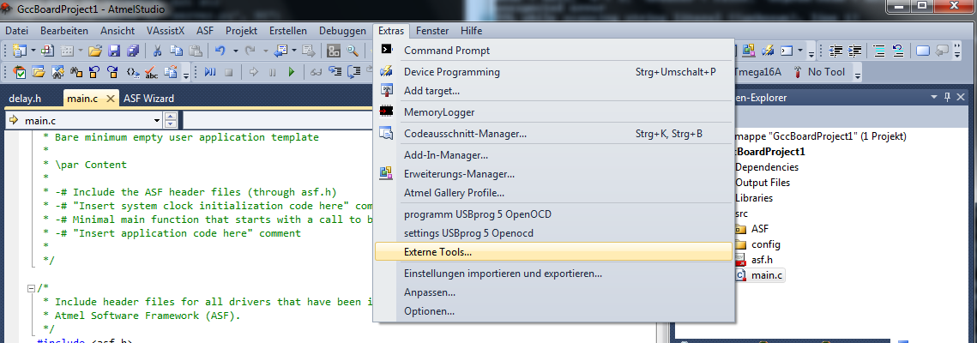Abbildung 31: Externe Tools

Entry„Program“
To create the entry „Program“ in Atmel Studio the following „Externe Tool“ needs to be created ( illustration 32 ) :
- Titel: Program with USBprog 5.0 Openocd
- Command: embeddedprog.exe
- Argument: --atmel-studio "$(TargetPath)"
The $(TargetPath) is the complete path to the target.elf file.It can be added by clicking the arroe next to Argument and selecting Target path.
- The last area dowsnt need to be filled.
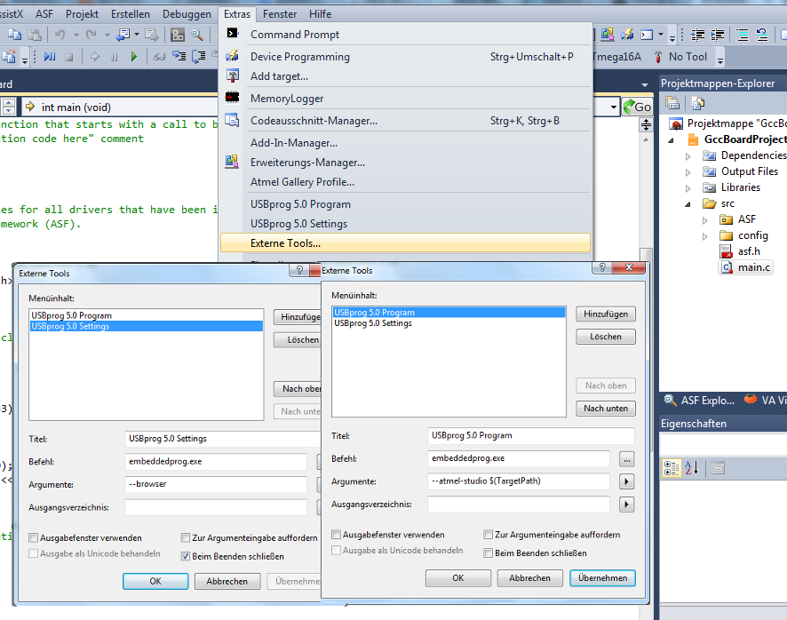Abbildung 32: Atmel-Studio Funktionen

Menu entry „Open Settings“
To change the settings via Atmel Studio, an additional entry has to be created. Its named „Open Settings“ ( illustration 32 ).
- Titel: Open Settings in Browser USBprog 5.0
- Command: embeddedprog.exe
- Argument: --browser

Using the Menu Entry
If both entrys are created and all tools are installed ( installation windows, page 8 ) the USBprog 5.0 can be used. Just create a project, compile it and programm with the External tool. ( illustration 33 ).

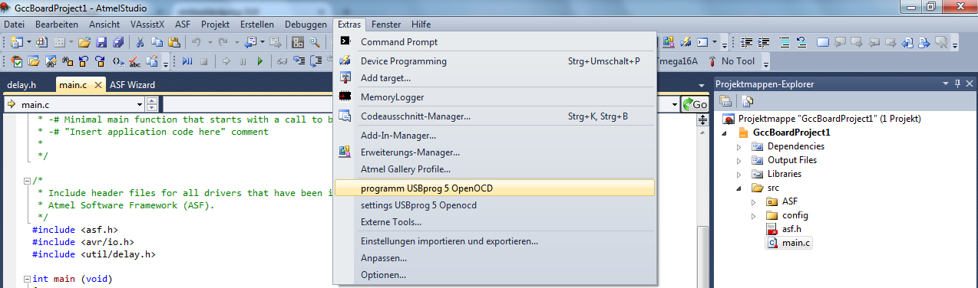Abbildung 33: Externes Tool Starten

If no processor was chosen via browser, the browser will open, where you should input the processor, target voltage and speed. ( illustration 34 ).
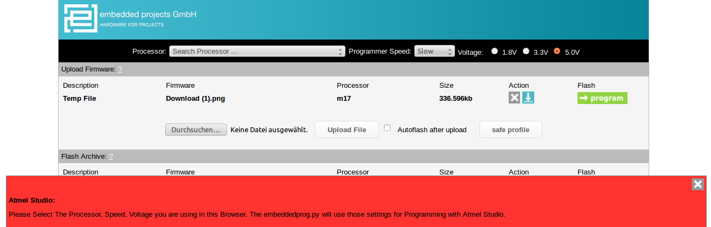Abbildung 34: Select Settings (Wichtig ist die rote Meldung)

If the correct settings are chosen the board will be programed with a click on the program USBprog point in the Tools tab. ( illustration 35 ).

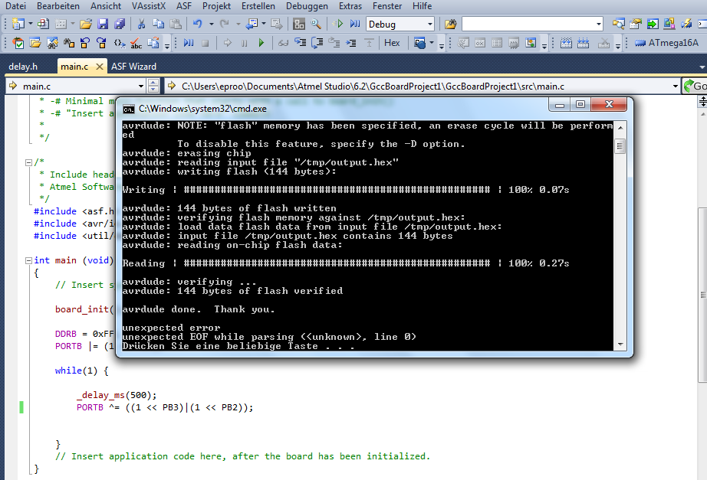Abbildung 35: Atmel Studio nach Flash

You can change the settings at any time in the browser. Use the tool "Open Settings in Browser" or connect directly to http://10.0.0.1 .

Einrichten des USBprog 5.0 als Programmer für Eclipse (not translated)
The USBprog 5.0 can be used in Eclipse as a programer. To do that you have to go to the External Tools Configuration. There you have to add the location of the commandline tool as well as the arguments. ( illustration 36).

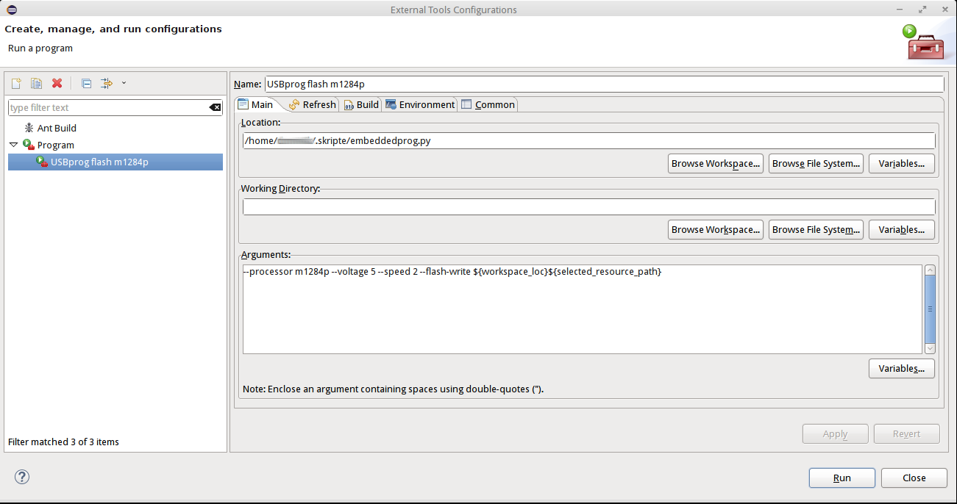Abbildung 36: External Tools Eclipse

its important to add the correct target commands of eclipse ( illustration 37).

Abbildung 37: Eclipse Arguments

In the Build tab, „Build before launch“ and „The project containing the selected resource“ should be selected ( illustration 38).
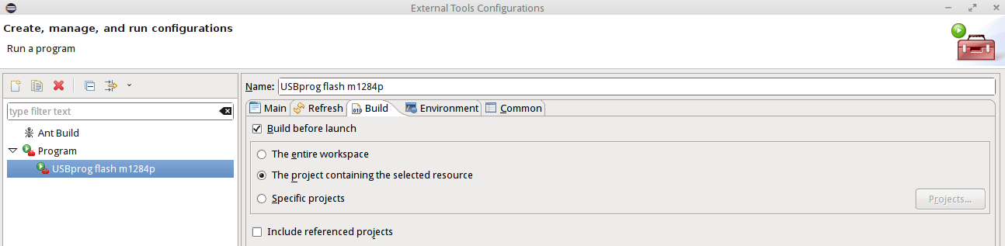Abbildung 38: BuildTab Eclipse

Then the Common tab needs to be editted. „Local file“,“External Tools“, „Default – inherited (UTF-8)“,“Allocate console“ as well as „Launch in Background“ should be selected. ( illustration 39)

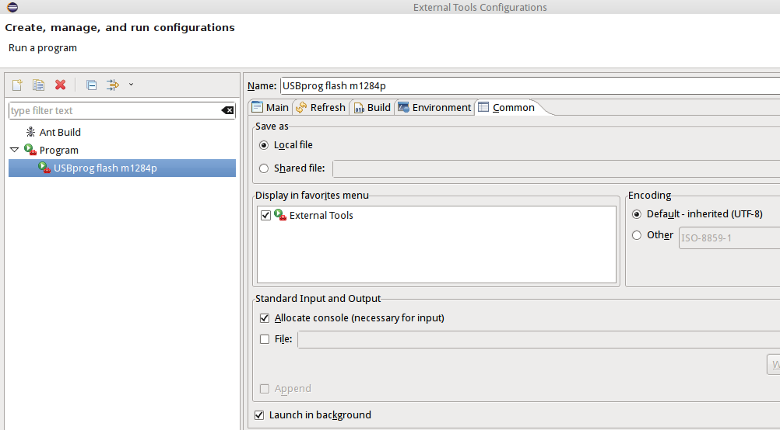Abbildung 39: Common Tab Eclipse

Now the USBporg can be used in eclipse ( illustration 40).
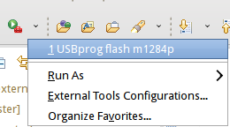Abbildung 40: Flash with Eclipse

Update Firmware
The newest Firmware for the USBprog 5.0 is aviable at following adress:
https://github.com/embeddedprojects/usbprog5/raw/master/update/update.tar.gz
To use this Update you first have to download the file update.tar.gz.
After that go to the intern USBprog 5.0 website locatet under http://10.0.0.1.
There click on browse button located in the Update programmer area.

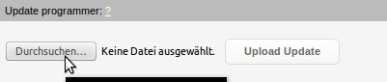Abbildung 41: Update Firmware

select the update.tar.gz .
Click Upload Update ( illustration 42 ).
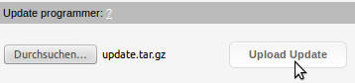Abbildung 42: Upload Firmware Update

now half the Screen gets white and shows in small letters „update in progress“. After a few moments you will be redirected and on a white page this time in big letters the text „update in progress“ will appear. After the update is finished you will be redirected to the USBprog startpage.

Debug with OpenOCD
With the USBprog you can debug ARM processors either via eclipse or via the Terminal, using the JTAG Interface

Debugging via Command line/Shell

Linux
To debug via the Terminal an apopriate tool has to be installed.
For example in case of the stm32f1x, gcc-arm-none-eabi-gdb ( https://launchpad.net/gcc-arm-embedded ) can be used as an gdb client.
To connect first openocd has to run on the USBprog 5.0, which can be started by either the embeddedprog.py/exe or the browser:

python embeddedprog.py --processor "processor" --gdb start

or

From the website (http://10.0.0.1) with the start openocd Button.

Command | Description | Ausgabe (bei einem stm32f1x)
gcc-arm-none-eabi-gdb <File> | Starts the gdb client. If a file is declared it can be used in later functions | GNU gdb (GNU Tools for ARM Embedded Processors) 7.6.0.20131129-cvs
target remote ip:port (10.0.0.1:3333) | Connects the gdb client with the USBprog 5.0 | (gdb) target remote 10.0.0.1:3333  Remote debugging using 10.0.0.1:3333
monitor | Is used to communicate with a remote target.
monitor reset | Resettets a Remote-Target | (gdb) monitor reset  JTAG tap: stm32f1x.cpu tap/device found: 0x3ba00477 (mfg: 0x23b, part: 0xba00, ver: 0x3)  JTAG tap: stm32f1x.bs tap/device found: 0x06420041 (mfg: 0x020, part: 0x6420, ver: 0x0)
monitor halt | Stopps the currently running program | (gdb) monitor halt  target state: halted  target halted due to debug-request, current mode: Thread  xPSR: 0x61000000 pc: 0x08000074 msp: 0x20001ff0
monitor step | Goes a step in the currently stopped program | (gdb) monitor step  target state: halted  target halted due to single-step, current mode: Thread  xPSR: 0x61000000 pc: 0x08000074 msp: 0x20001ff0
list | Shows the current code if a file was atached. | (gdb) list  23  24  25 for(i=0; i < 10; i++){  26 int_debug = int_debug + i * (i*i) + int_debug_value;  27 }
load | Loads the file in the memory if it was atached | (gdb) load  Loading section vectors, size 0x40 lma 0x8000000  Loading section .text, size 0x90 lma 0x8000040  Loading section .data, size 0x4 lma 0x80000d0  Start address 0x8000044, load size 212
q,quit | Ends the debug session | Detaching from program: main.elf, Remote target  Ending remote debugging.

Exemplary usage of the commands (using stm32f1x):
while compiling the program with -g you can add debug infos into the .elf file.
Now we start the gdb with the atached file.

:~$ /gcc-arm-none-eabi/bin/arm-none-eabi-gdb /Pfad zur Datei/main.elf

this yields following output:

GNU gdb (GNU Tools for ARM Embedded Processors) 7.6.0.20131129-cvs
Copyright (C) 2013 Free Software Foundation, Inc.
License GPLv3+: GNU GPL version 3 or later <http://gnu.org/licenses/gpl.html>
This is free software: you are free to change and redistribute it.
There is NO WARRANTY, to the extent permitted by law. Type "show copying"
and "show warranty" for details.
This GDB was configured as "--host=i686-linux-gnu --target=arm-none-eabi".
For bug reporting instructions, please see:
<http://www.gnu.org/software/gdb/bugs/>...
Reading symbols from /home/Pfad zur Datei/main.elf...done.

Now to connect to the USBprog 5.0:

(gdb) target remote 10.0.0.1:3333

main () at main.c:36
36 i=1 ;

stopping the target:

(gdb) monitor reset halt

JTAG tap: stm32f1x.cpu tap/device found: 0x3ba00477 (mfg: 0x23b, part: 0xba00, ver: 0x3)
JTAG tap: stm32f1x.bs tap/device found: 0x06420041 (mfg: 0x020, part: 0x6420, ver: 0x0)
target state: halted
target halted due to debug-request, current mode: Thread
xPSR: 0x01000000 pc: 0x08000044 msp: 0x20002000

load the .elf file:
(gdb) load

Loading section vectors, size 0x40 lma 0x8000000
Loading section .text, size 0x90 lma 0x8000040
Loading section .data, size 0x4 lma 0x80000d0
Start address 0x8000044, load size 212

(gdb) monitor reset halt

JTAG tap: stm32f1x.cpu tap/device found: 0x3ba00477 (mfg: 0x23b, part: 0xba00, ver: 0x3)
JTAG tap: stm32f1x.bs tap/device found: 0x06420041 (mfg: 0x020, part: 0x6420, ver: 0x0)
target state: halted
target halted due to debug-request, current mode: Thread
xPSR: 0x01000000 pc: 0x08000044 msp: 0x20002000

stepping through the program;

(gdb) step

RESET_Handler () at startupcode.c:8
8 main();

(gdb) step

Note: automatically using hardware breakpoints for read-only addresses.
main () at main.c:18
18 int_debug = int_debug + int_debug_value;

(gdb) step

26 int_debug = int_debug + i * (i*i) + int_debug_value;

(gdb) quit

A debugging session is active.

Inferior 1 [Remote target] will be detached.

Quit anyway? (y or n) y

Debuggen mit Eclipse ( not yet Documented )
- Eine Anleitung folgt.

USBprog 5.0 System details

Open-Source Programs
The Usbprog 5.0 is running on a Linux system. The connection to the target board is established via SPI, to create fast JTAG sequenzes.
The core of the USBprog 5.0 is the server.py which connects with the browser and the commandline tool.

The webpage, which is written in PHP is located in the folder /var/www. For programming an debugging the tools Avrdude and Openocd are used. The source code can be viewed in the git repository.

GPIO Routing

OpenOCD | Avrdude | gpios | pin | pin | gpios | avrdude | OpenOCD
TDO | MOSI | GPIO 18 | 1 | 2 | vcc
TCK |  | GPIO 17 | 3 | 4 | GPIO 16
TDI | RESET | GPIO 2 | 5 | 6 | GPIO 13 |  | TMS
 | SCK | GPIO 20 | 7 | 8 | GPIO 12 |  | TRST
 | MISO | GPIO 19 | 9 | 10 | gnd
Table 5: GPIO 10-polige Buchse

Beschreibung | Pin | Pin | Beschreibung
GPA0 | 1 | 2 | GPA1
GPA2 | 3 | 4 | PWM
SCL | 5 | 6 | SDA
MOSI | 7 | 8 | MISO
SYSCLOCK | 9 | 10 | SPI SCK
GPIO14 | 11 | 12 | GPIO11
3.3V | 13 | 14 | GND
Table 6: 14-polige Gnublin/EEC Buchse

Abbildungsverzeichnis
Abbildung 1: USBprog 5.0 5
Abbildung 2: ARM 10 auf 20 5
Abbildung 3: AVR 10 auf 6 5
Abbildung 4: Systemsteuerung öffnen 8
Abbildung 5: Geräte-Manager wählen 9
Abbildung 6: RNDIS Gadget aktualisieren 9
Abbildung 7: Auf dem Compuiter nach Software suchen 10
Abbildung 8: Aus Liste auswählen 10
Abbildung 9: Netzwerkadapter 11
Abbildung 10: Microsoft Corporation Remote NDIS 12
Abbildung 11: suche Geräte-Manager 13
Abbildung 12: RNDIS Gadget aktualisieren 13
Abbildung 13: Auf dem Compuiter nach Software suchen 14
Abbildung 14: Treiber aus Liste 14
Abbildung 15: Netzwerkadapter 15
Abbildung 16: USB-RNDIS-Adapter 16
Abbildung 17: Warnmeldung 16
Abbildung 18: Browser 18
Abbildung 19: Konsole 18
Abbildung 20: Settings 18
Abbildung 21: Buttons AVR 19
Abbildung 22: Buttons ARM 19
Abbildung 23: Temporäre Firmware in der ARM Oberfläche 19
Abbildung 24: Temporäre Firmware in der AVR Oberfläche 20
Abbildung 25: Flasharchive 20
Abbildung 26: Kommandozeilenbefehle ARM 20
Abbildung 27: Kommandozeilenbefehle AVR 21
Abbildung 28: Ausführen mit Windows 21
Abbildung 29: Spotlight zum Aufruf des Terminal in MacOS 22
Abbildung 30: update programmer/ download Konsolen tool 22
Abbildung 31: Externe Tools 25
Abbildung 32: Atmel-Studio Funktionen 26
Abbildung 33: Externes Tool Starten 27
Abbildung 34: Select Settings (Wichtig ist die rote Meldung) 27
Abbildung 35: Atmel Studio nach Flash 28
Abbildung 36: External Tools Eclipse 29
Abbildung 37: Eclipse Arguments 29
Abbildung 38: BuildTab Eclipse 30
Abbildung 39: Common Tab Eclipse 30
Abbildung 40: Flash with Eclipse 31
Abbildung 41: Update Firmware 31
Abbildung 42: Upload Firmware Update 31

Tabellenverzeichnis
Tabelle 1: Common Arguments 23
Tabelle 2: Config Arguments 23
Tabelle 3: ARM Arguments 23
Tabelle 4: AVR Arguments 24
Table 5: GPIO 10-polige Buchse 35
Table 6: 14-polige Gnublin/EEC Buchse 36

Stichwortverzeichnis

